Exp-6: Confluence to streamline task tracking in jira & confluence

Step 1- Create the account in confluence and open the page


Step 2- Create the page by clicking the create option

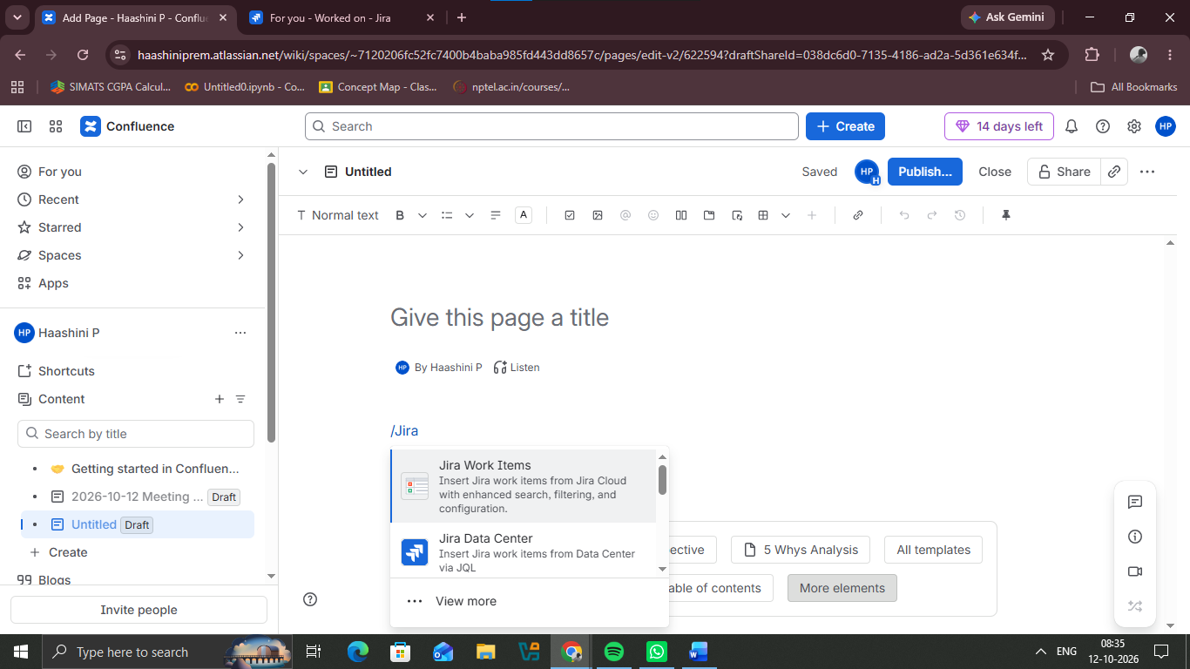
Step 3- Select the jira platform to connect with the confluence

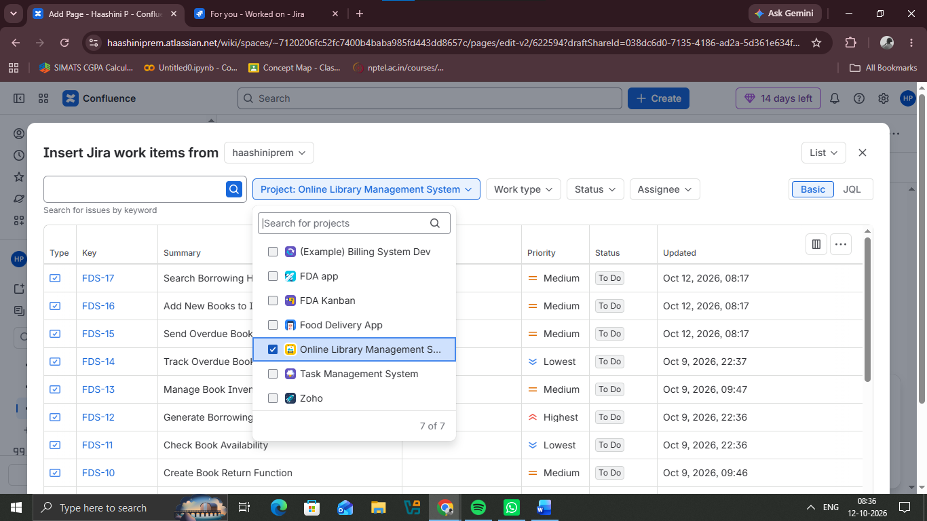
Step 4- In the project searching space select the project from the jira

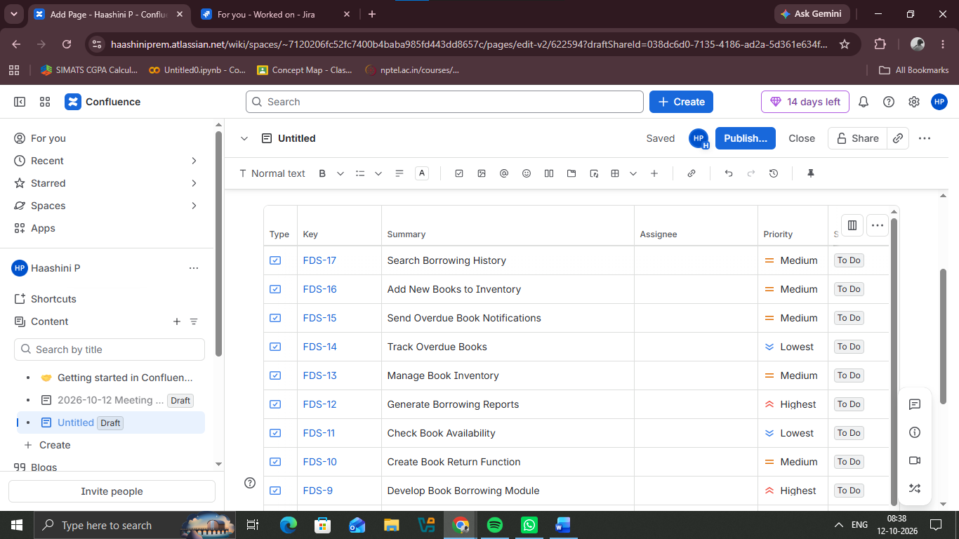
Step 5- After connecting the jira to confluence the task will be displayed in confluence

